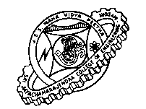
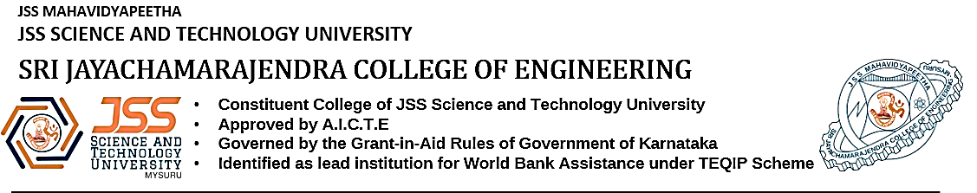 DEPARTMENT OF ELECTRONICS AND COMMUNICATION
VI Sem ‘A’ and ‘B’ Section
EC640: Optical fiber communication
First Test
Date: 18-05-2021 Max. Marks: 20
Time: 4:00PM – 5:15PM Duration: 1hr 15 mins
Course outcomes covered:
CO2: Explain and analyze the principles of signal, degradation in fiber, source and detector in optical communication
Cognitive Domains:
L1: - Remembering L2: - Understanding L3: - Applying L4: - Analyzing L5: -Evaluating L6: -Creating
Answer the following questions:
Q. No | COs | Questions | Cognitive Domain | Marks
Q1 | CO2 | An LED having a circular emitting area of radius 40 µm and a lambertian emission pattern with 120W/cm²sr axial radiance at a given 15mA drive current. Compare the optical powers coupled into two step index fibers, one of which has a core radius of 20µm with numerical aperture of 0.22. Comment on the results | L4 | 05
Q2 | CO2 | A double heterojunction InGaAsP LED operating at 850 nm has radiative and non-radiative recombination times of 50 and 110 ns respectively. The current injected is 40 mA. Calculate the bulk recombination life time, internal quantum efficiency internal power level. | L3 | 05
Q3 | CO2 | List the advantages and disadvantages of Laser diode | L2 | 05
OR
Q4 | CO2 | Explain the power current characteristics of the laser diode | L2 | 05
Q5 | CO2 | Outline the different lensing schemes to improve the coupling efficiency | L2 | 05
OR
Q6 | CO2 | Differentiate between butt joint and expanded beam connectors | L2 | 05

